
SERVICE MANUAL

DRYER MACHINE
Service Manual

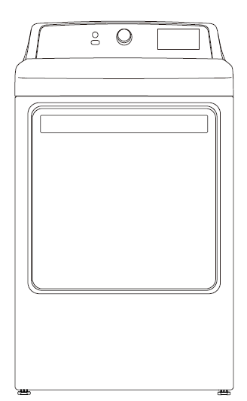
INSIGNIA Models:

NS-TDRE75W1
NS-TDRG75W1

<7.5Cu.Ft Electric and Gas Dryer, White >

CAUTION
READ THIS MANUAL CAREFULLY TO DIAGNOSE TROUBLES CORRECTLY BEFORE OFFERING SERVICE.
CONTENTS

1. PRECAUTION 3
1.1 Safety precaution 3
1.2 Warning 3
1.3 Caution 5
2. How to use 6
2.1 Controls and function 6
2.2 Cycle guide with option settings 8
3. DIMENSION and INSTALLATION 10
3.1 Unit dimensiont 10
3.2 Installation 11
4. TROUBLE SHOOTING 23
4.1 Test mode by Control 23
4.2 Test modes 23
4.3 Error codes 24
4.4 Wiring diagram and terminals 25
4.5 Trouble shooting 27
5. HOW TO DISASSEMBLY THE UNIT 31
6. EXPLODED VIEW 42
7. SPARE PART 44
8. SPECIFICATION 48

1. PRECAUTION

1.1 Safety precaution
For your safety the information in this manual must be followed to minimize the risk of fire or explosion, or to prevent property damage, personal injury or death.
– Do not store or use gasoline or other flammable vapors and liquids in the vicinity of this or any other appliance.
– WHAT TO DO IF YOU SMELL GAS:
• Do not try to light any appliance.
• Do not touch any electrical switch; do not use any phone in your building.
• Clear the room, building, or area of all occupants.
• Immediately call your gas supplier from a neighbor’s phone. Follow the gas supplier’s instructions.
• If you cannot reach your gas supplier, call the fire department.
– Installation and service must be performed by a qualified installer, service agency, or the gas supplier.

1.2 Warning

- Do not dry items that have been previously cleaned, washed, soaked, or spotted with gasoline, dry cleaning solvents, or other flammable or explosive substances. They emit vapors that could ignite or explode. Any material that has been in contact with a cleaning solvent or flammable liquids or solids should not be placed in the dryer until all traces of these flammable liquids or solids and their fumes have been removed.
- There are many highly flammable items used in homes, such as acetone, denatured alchohol, gasoline, kerosene, some liquid household cleaners, some spot removers, turpentine, waxes, and wax removers.
- Do not dry items containing foam rubber (may be labeled latex foam) or similarly textured rubber-like materials on a heat setting. Heated foam rubber materials can, under certain circumstances, produce fire by spontaneous combustion.
- Clothes dryer installation must be performed by a qualified installer.
- Install the clothes dryer according to the manufacturer’s instructions and local codes.
- Do not install a clothes dryer with flexible plastic venting materials. If flexible metal (foil type) duct is installed, it must be of a specific type identified by the appliance manufacturer as suitable for use with clothes dryer. Flexible venting materials are known to collapse, be easily crushed, and trap lint. These conditions will obstruct with the clothes dryer’s airflow and increase the risk of fire.
- To reduce the risk of severe injury or death, follow all installation instructions.
- Read all instructions before using the appliance.
- Use this appliance only for its intended purpose as described in this Owner’s Manual.
- Before use, the dryer must be properly installed as described in this manual.
- ALWAYS follow the fabric care instructions supplied by the garment manufacturer.
- Do not dry articles that have been previously cleaned in, washed in, soaked in, or spotted with gasoline, dry-cleaning solvents, other flammable or explosive substances as they give off vapors that could ignite or explode.
- Do not use the dryer to dry clothes which have traces of any flammable substance, such as vegetable oil, cooking oil, machine oil, flammable chemicals, thinner, etc., or anything containing wax or chemicals, such as mops and cleaning clothes. Flammable substances may cause the fabric to catch fire by itself.
- Do not store or use gasoline or other flammable vapors and liquids near this or any other appliance.
- Do not allow children to play on or in the appliance. Close supervision of children is necessary when the appliance is used near children.
- Before the appliance is removed from service or discarded, remove the lid of the washing or door of the drying compartment.
- Do not reach into the appliance if the drum is moving.
- Do not install or store this appliance where it will be exposed to the weather or freezing temperatures.
- Do not tamper with the controls.
- Do not repair or replace any part of the appliance or attempt any servicing unless it is specifically recommended in the ser-maintenance instructions or in published user-repair instructions that you understand and have the skills to carry out.
- Keep the area underneath and around your appliances free of combustible materials (lint, paper, rags, etc.), gasoline, chemicals and other flammable vapors and liquids.
- Do not place items exposed to cooking oils in your washer. Items contaminated with cooking oils may contribute to a chemical reaction that could cause a load to catch fire.
- Turn off the water faucets and unplug the washer if the machine is to be left for an extended period of time, such as during vacations.
- Packaging material can be dangerous for children. There is a risk of suffocation! Keep all packaging from children.
- Always check the inside of the dryer for foreign objects before loading laundry. Keep the door closed when not in use.
- Do not use fabric softeners or products to eliminate static unless recommended by the manufacturer of the fabric softener or product.
- Clean the lint screen before or after each load.
- Keep the area around the exhaust opening and surrounding areas free from lint, dust, and dirt.
- The interior of the dryer and exhaust duct should be cleaned periodically by qualified service personnel.
- Do not place items exposed to cooking oils in your dryer. Items contaminated with cooking oils may contribute to a chemical reaction that could cause a load to catch fire.
- This appliance must be grounded. See “Electrical requirements” and “Grounding” in the “Installation Steps” section.
- This appliance must be properly grounded. Never plug the power cord into a receptacle that is not grounded adequately and in accordance with local and national codes. Refer to installation instructions for grounding this appliance.
- Ensure pockets are free from small irregularly shaped hard objects and foreign material, i.e. coins, knives, pins, etc. These objects could damage your dryer.
- Gas leaks may occur in your system, resulting in a dangerous situation.
- Gas leaks may not be detected by smell alone.
- Gas suppliers recommend you purchase and install a UL approved gas detector.

1.3 Caution

- Do not sit on top of the dryer.
- Because of continuing product improvements, we reserve the right of change specifications without notice. For complete details, see the Installation Instructions packed with your product before selecting cabinetry, making cutouts, or beginning installation.
- Do not dry clothing with large buckles, buttons, or other heavy metal or solid things.
- Install and use in accordance with the manufacturer’s instructions.
- Do not place items in your dryer that have been spotted or soaked with vegetable oil or cooking oil. Even after being washed, these items may contain significant amounts of these oils.
- Residual oil on clothing can ignite spontaneously. The potential for spontaneous combustion increases when items containing vegetable oil or cooking oil are exposed to heat. Heat source such as your dryer can warm these items, allowing an oxidation reaction in the oil to occur.
- Oxidation creates heat. If this heat cannot escape, the items can become hot enough to catch fire. Piling, stacking, or storing these kinds of items may prevent heat from escaping and can create a fire hazard.
- Take care that children’s fingers are not caught in door when closing it. This may result in injury.

2. How to use

2.1 Controls and function

- Power button
Press to turn your dryer on or off. If your dryer is on for more than 10 minutes without any buttons being pressed, it automatically turns off.
- Cycle selector
Turn to select the cycle for the type of load. The cycle you select determines the heat control for the cycle. The Normal, Delicates, Casual, Towels, Sanitize, Heavy Duty, and Bulky
cycles are Sensor dry cycles. The Quick Dry, Time Dry, and Air Fluff cycles are Manual dry
cycles.
- Digital display
Displays the time while you are pressing the Time Adjust button to set the time for the
Quick Dry, Time Dry, or Air Fluff cycle.Displays the remaining cycle time while your dryer is running.
- Time Adjust button
Press repeatedly to select the drying time. This button only works for the Quick Dry, Time
Dry, and Air Fluff cycles.
- Wrinkle Prevent button
Press once to add the Wrinkle Prevent step to the drying cycle. Press again to cancel.
Wrinkle Prevent provides approximately 90 minutes of intermittent tumbling in unheated
air at the end of the cycle to reduce wrinkling. The load is already dry and can be removed at
any time during the Wrinkle Prevent cycle.
- Start /Pause button
Press to start or pause the drying cycle. When you pause the cycle, you can add items to the
dryer, but your cannot change any settings.

- Cycle status indicators
Indicate what stage in the drying cycle your dryer is in. For example, when your dryer is in
the cooling down stage of the cycle, the Cooling indicator lights. When the cycle is complete, the Clean Filter indicator flashes to remind you to clean the filter.
- My Cycle button
Press and hold for three seconds to save your favorite drying cycle. Press once to load your
favorite cycle setting.
- Dryness button
Press to select the dryness level. Different dryness levels result in different drying times. For
clothes to be ironed manually, select a lower dryness level.
- Child Lock
Press and hold the Dryness and Temp buttons at the same time for three seconds to
turn on the child lock function. Press and hold for three seconds to turn off the function.
When the child lock function is turned on, the only button that works is the Power button .
- Temp button
Press to select the drying temperature. Your can select High, Medium, Low, Ultra Low, or
No Heat. Temperature changes are only available on Quick Dry and Time Dry settings.

2.2 Cycle guide with option settings
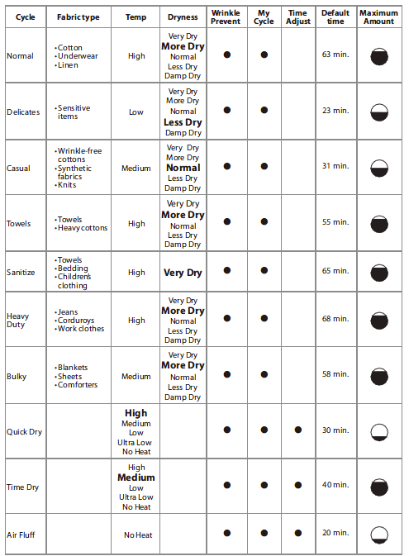

* For the Bulky cycle , the dryer will adjust the display time according to the load, “A” means “10" and “B” means “11". For example, “A5" means “105min” and “B5" means “115min” .
* Table in grey is an initial setting. Dots are all optional functions you can select.
Load Size Recommendations:
For best results, follow the wet load size recommendations noted for each cycle.
Small load: Fill the dryer drum with 3-4 items, not more than 1/4 full.
Medium load: Fill the dryer drum up to about 1/2 full.

Large load: Fill the dryer drum up to about 3/4 full. Do not overload. Items need to tumble freely

3. DIMENSION and INSTALLATION

3.1 Unit dimensiont
The dryer should be located where there is enough space at the front for loading the dryer, and enough space behind for the exhaust system.
- This dryer is factory-ready for the rear exhaust option. To exhaust out the bottom or left, use the accessory exhaust kit. Instructions are included with the kit.
- Make sure the room in which the dryer is located has enough fresh air. The dryer must be located where there are no air-flow obstructions.
For gas dryers, adequate clearance must be maintained as noted on the data plate to ensure adequate air for combustion and the proper dryer operation.
The dryer must not be installed or stored in an area where it will be exposed to water and/or weather. The dryer area must be kept clear of combustible materials, gasoline, and other flammable vapors and liquids. A dryer produces combustible lint. The area around the dryer should be kept lint-free.

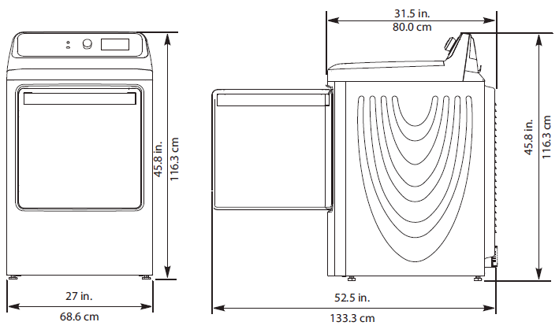
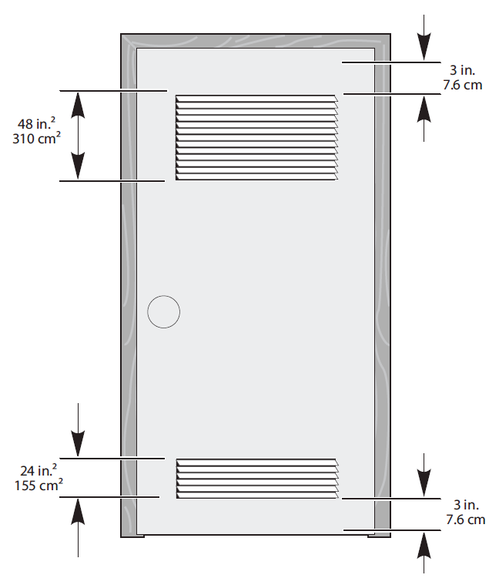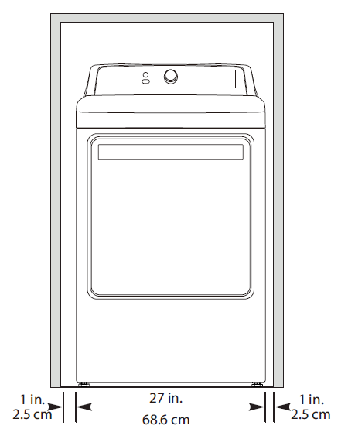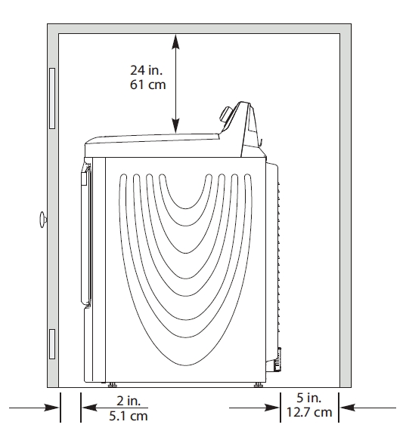
Alcove or closet installations
The dryer must be exhausted to the outside to reduce the risk of fire when installed any place inside the house.
- No other fuel-burning appliance should be installed in the same closet as the dryer.
- Refer to the “Exhausting” section below for installation of exhausting work.
- The front of the closet must have two unobstructed air openings for a combined minimum total area of 72 sq.in. (465 sq.cm) with a minimum clearance of 3 in. (76mm) at the top and bottom. A slatted door with equivalent space clearance is acceptable.
- Minimum clearances between the dryer and adjacent walls or other surfaces are as:
Either side 1 in. / 2.5cm
Rear 5 in. / 12.7cm
Top 11 in. / 27.9cm
Front 2 in. / 5.1cm

3.2 Installation
TOOLS needed in installation
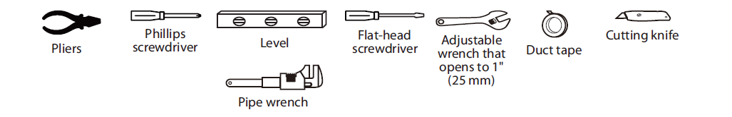

Materials you will need
• 3/8’ Gas Dryer Install Kit (Gas model only)
• 3 or 4-prong (dependent on owners house) Electric Kit, Phillips screwdriver. (electric model only)
• Exhaus t kit

Ducting Requirements
- Use a 4-inch (10.2cm) diameter rigid aluminum or rigid galvanized steel duct.
- Do not use a smaller duct.
- Ducts larger than 4 inches (10.2cm) in diameter can result in increased accumulation of lint.
- Lint should be removed regularly.
- If a flexible metal duct must be used, use the type with a stiff sheet metal wall. Do not use a flexible duct with a thin foil wall. A serious blockage can result if the flexible metal duct is bent too sharply.
- Never install any type of flexible duct in walls, ceilings, or other concealed spaces.
- Keep the exhaust duct as straight and short as possible.
- Secure joints with duct tape. Do not use screws.
- Plastic flexible ducts can kink, sag, be punctured, reduce airflow, extend drying times, and affect the dryer operation.
- Exhaust systems longer than recommended can extend drying times, affect machine operations, and collect lint.
- The exhaust duct should end with an exhaust hood with a swing-out damper to prevent back drafts and entry of wildlife. Never use an exhaust hood with a magnetic damper.
- The hood should have at least 12 inches (30.5cm) of clearance between the bottom of the hood and the ground or other obstruction. The hood opening should point down.
- Never install a screen over the exhaust outlet.
- To avoid lint buildup, do not exhaust the dryer directly into a window well. Do not exhaust under a house or porch.
- If the exhaust duct must run through an unheated area, the duct should be insulated and slope slightly down towards the exhaust hood to reduce condensation and lint buildup.
- Inspect and clean the interior of the exhaust system at least once a year. Unplug the power cord before cleaning.
- Check frequently to make sure the exhaust hood damper opens and closes freely.
- Check once per month, and clean at least once per year. Note: If your clothes are not getting dry, then check the ducting for obstructions.
- Do not exhaust the dryer into a wall, ceiling, crawl space, or concealed space of a building, gas vent, or any other common duct or chimney. This could create a fire hazard from the lint expelled by the dryer.
- Do not use non-metallic flexible duct.
- To reduce the risk of fire, this dryer must be exhausted outdoors.
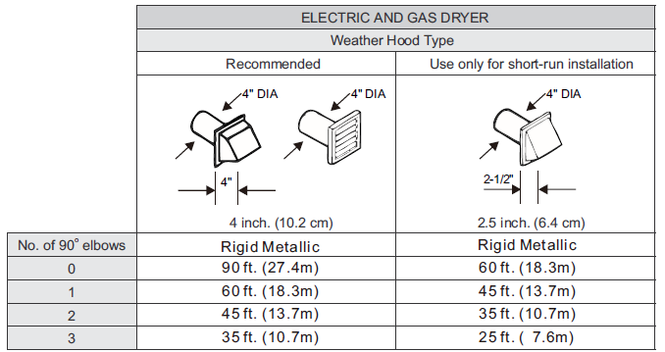
If this new dryer is installed into an existing exhaust system you must make sure:
- The exhaust system meets all local, state, and national codes.
- That a flexible plastic duct is not used.
- To inspect and clean all lint buildup from inside the existing duct.
- The duct is not dented or crushed.
- The exhaust hood damper opens and closes freely.

The static pressure in any exhaust system for best results shall be between 0.3 to 0.8 inches of water column, and cannot be less than 0 under any circumstances. with installed duct of 4 inch diameter. Measurement must be done with the empty dryer working with a manometer at the point where the exhaust duct connects to the dryer. A no-heat setting should be used. Lint filter must be clean.

Please read the following instructions carefully before installing the dryer. These instructions should be kept for future reference.
- The dryer is not suitable for installation in a mobile home.
- Remove the door from all discarded appliances to avoid the danger of a child being trapped and suffocating, after unplugging cut off Power Cord.
Exhausting
The dryer shall not be exhausted into a chimney, a wall, a ceiling, an attic, a crawl space, or a concealed space of a building.
The dryer must be exhausted to the outside to reduce the risk of fire when installed in alcove or closet.
Exhausting the dryer to the outside will prevent large amounts of lint and moisture from being blown into the room.
NEVER USE A PLASTIC OR NON-METAL FLEXIBLE DUCT
If your existing ductwork is plastic, non-metal, or combustible, replace it with metal.
Use only a metal exhaust duct that is non-flammable to ensure containment of the exhaust air heat, and lint.
Refer to the “Ducting requirements” section on page 11 for the maximum duct length and number of bends.
- All dryers must be exhausted to the outside.
- Do not assemble the duct with screws or other fastening means that extend into the duct and catch lint.
- The exhaust duct should be 4 inches (102mm) in diameter.
- The total length of flexible metal duct shall not exceed 7.8 feet (2.4 meters).
For usage in United States:
Use only those foil-type flexible ducts, if any, specifically identified for use with the appliance by the manufacturer and that comply with the outline for Clothes Dryer Transition Ducts, Subject 2158A, shall be used.
For usage in Canada:
Use only those foil-type flexible ducts, if any, specifically identified for use with the appliance by the manufacturer.
For usage outside the U.S. and Canada:
Refer to the local codes.

Gas requirements
Use only natural or LP (liquid propane) gases.
THE INSTALLATION MUST CONFORM WITH LOCAL CODES, OR IN THE ABSENCE OF LOCAL CODES, WITH THE NATIONAL FUEL GAS CODE, ANSI Z223.1/NFPA 54, LATEST REVISION (FOR THE UNITED STATES), OR THE NATURAL GAS AND PROPANE INSTALLATION CODE, CSA B149.1, LATEST REVISION (FOR CANADA).
Gas dryers are equipped with a burner vent for use with natural gas. If you plan to use your dryer with LP (liquid propane) gas, it must be converted for safe and proper performance by a qualified service technician.
A ½" (1.27cm) gas supply line is recommended and must be reduced to connect to the 3/8" (1cm) gas line on your dryer. The National Fuel Gas Code requires that an accessible, approved manual gas shut-off valve be installed with 6" of your dryer.
Gas dryers installed in residential garages must be raised 18" (46cm) above the floor.
Additionally, a 1/8" (0.3cm) N.P.T. (National Pipe Thread) plugged tapping, accessible for test gauge connection, must be installed immediately upstream of your dryer’s gas supply connection.
Your dryer must be disconnected from the gas supply pipe system during any pressure testing of the system.
This dryer must be connected to the gas supply piping with a listed flexible gas connector that complies with the standard for connectors for gas appliances, ANSI Z21.24 or CSA 6.10.
DO NOT reuse old flexible metal gas lines. Flexible gas lines must be design certified by the American Gas Association (CGA in Canada).
- Any pipe joint compound used must be resistant to the action of any liquefied petroleum gas.
- As a courtesy, most local gas utilities will inspect a gas appliance installation.
GAS IGNITION - Your dryer uses an automatic ignition system to ignite the burner. There is no constant burning pilot.
COMMONWEALTH OF MASSACHUSETTS INSTALLATION INSTRUCTIONS
Your dryer must be installed by a licensed plumber or gas fitter. A “T” handle manual gas valve must be installed in the gas supply line to installed dryer at location of operation.
If a flexible gas connector is used to install your dryer, the connector may not be longer than 3' (36", 91.5cm).
- Gas leaks may occur in your system, creating a dangerous situation.
- Gas leaks may not be detected by smell alone.
- Gas suppliers recommend that you purchase and install a UL-approved gas detector.
- Install and use it in accordance with the manufacturer’s instructions.

Electric requirements
An individual branch (or separate) circuit serving only your dryer is recommended. DO NOT USE AN EXTENSION CORD.

Gas models - U.S. and Canada
A 120Volt, 60Hz AC approved electrical service, with a 15 ampere fuse or circuit breaker is required.

Electric models - U.S. only
Most dryers require a 120/240 volt, 60Hz AC approved electrical service. Some require 120/208 volt, 60Hz approved electrical service. The electric service requirements can be found on the data label located behind the door. A 30-amperefuse or circuit breaker on both sides of the line is required.
- If a power cord is used, the cord should be plugged into a 30-ampere receptacle.
- The power cord is NOT provided with U.S. electric model dryers.
RISK OF ELECTRIC SHOCK:
When local codes allow, the electrical supply of the dryer may be connected by means of a new power supply cord kit, marked for use with a dryer, that is UL listed and rated at a minimum of 120/240 volts, 30-ampere with three No. 10 copper wire conductors terminated with closed loop terminals, open-end spade lugs with turned up ends, or with tinned leads.
- Do not reuse a power supply cord from an old dryer. The power cord electric supply wiring must be retained at the dryer cabinet with a suitable UL-listed strain relief.
- Grounding through the neutral conductor is prohibited for (1) new branch-circuit installations, (2) mobile homes, (3) recreational vehicles, and (4) areas where local codes prohibit grounding through the neutral conductor. (Use a 4-prong plug for 4 wire receptacles, NEMA type 14-30R.)

Three wire outlet
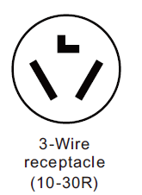
Then choose a 3-wire power supply cord with ring or spade terminals and UL listed strain relief. The 3-wire power supply cord, at least 4 ft. (1.22 m) long, must have 3 10-gauge solid copper wires and match a 3-wire receptacle of NEMA Type 10-30R.

3-Wire system connections
1. Remove the center terminal block screw.
2. Connect the neutral wire (white or center wire) of the power cord to the center. Cross the screw through the ring of the power cord terminal and tighten the screw.
3. Connect the other wires to the outer terminal block screws. Be sure to cross the screw through the terminal ring and tighten the screw.
4. Remove the screws for the power cord fixing base. Cross the power cord to the base, then install back and tighten the screws. Be sure to fix the power cord tightly.
5. Insert the tab of the terminal block cover into your dryer’s rear panel slot.
6. Secure the cover with a hold-down screw.
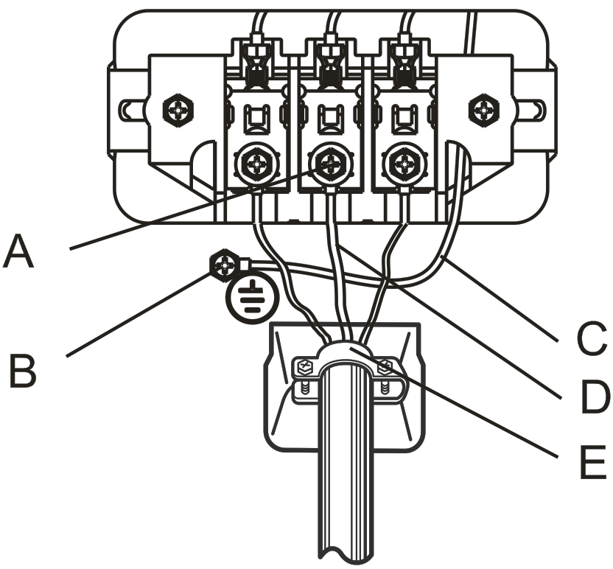

3-wire system instructions:
A. Center terminal block screw
B. external ground connector
C. Neutral grounding wire (White)
D. Neutral wire (white or center wire)
E. 3/4" (1.9cm) UL-listed strain relief
- If converting from a 4-wire electrical system to a 3-wire,
the ground strap must be reconnected to the terminal block
support to ground the dryer frame to the neutral conductor.

Four wire outlet
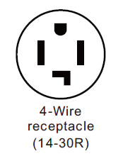
Then choose a 4-wire power supply cord with ring or spade terminals and UL listed strain relief. The 4-wire power supply cord, at least 4 ft. (1.22 m) long, must have 4
10-gauge solid copper wires and match a 4-wire receptacle of NEMA Type 14-30R. The ground wire (ground conductor) may be either green or bare. The neutral conductor must be identified by a white color.

4-Wire system connections
1. Remove the center terminal block screw.
2. Connect the ground wire (green or unwrapped) of the power cord to the external ground conductor screw.
3. Connect the neutral wire (white or center wire) of the power cord and the appliance ground wire (white) under the center screw of the terminal block. Cross the screw through the ring of wires’ terminal and tighten the screw.
4. Connect the other wires to the outer terminal block screws. Be sure to cross the screw through the terminal ring and tighten the screw.
5. Remove the screws for the power cord fixing base. Cross the power cord to the base, then install back and tighten the screws. Be sure to fix the power cord tightly.
6. Insert the tab of the terminal block cover into your dryer’s rear panel slot.
7. Secure the cover with a hold-down screw.

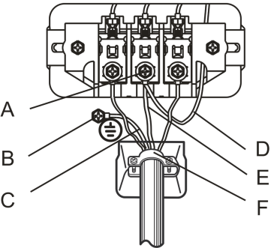
4-wire system instructions:
A. Center terminal block screw
B. External ground connector
C. Green or bare copper wire of the power cord
D. Neutral grounding wire (White)
E. Neutral wire (white or center wire)
F. 3/4" (1.9cm) UL-listed strain relief

Gas models
- Your dryer has a cord with an equipment-grounding conductor and a grounding plug.
- The plug must be plugged into an appropriate outlet that is properly installed and grounded in accordance with all local codes and ordinances.
- Do not modify the plug provided with your dryer - if it doesn’t fit the outlet, have a proper outlet installed by a qualified electrician.
- Never connect the ground wire to the plastic plumbing lines, gas lines, or hot water pipes.
Electric models
- For products sold in the U.S., your dryer has an optional cord with an equipment-grounding conductor and a grounding plug, which is sold separately.
For products sold in Canada, your dryer has a cord with an equipment-grounding conductor and a grounding plug.
- The plug must be plugged into an appropriate outlet that is properly installed and grounded in accordance with all local codes and ordinances.
- Do not modify the plug provided with your dryer - if it doesn’t fit the outlet, have a proper outlet installed by a qualified electrician.
- If a power cord is not used and the electric dryer is to be permanently wired, the dryer must be connected to a permanently grounded metal wiring system, or an equipment grounding conductor must be run with the circuit conductors and connected to the equipment grounding terminal or lead on the dryer.
Electric models - Canada only
- A 120/240 volt, 60Hz AC approved electrical service fused through a 30-ampere fuse or circuit breaker on both sides of the line is required.
- All Canadian models are shipped with the power cord attached. The power cord should be plugged into a 30-ampere receptacle.
In Canada, you may not convert a dryer to 208 volts.

The wiring diagram is located on the back board of the unit.
- The improper connection of the equipment grounding conductor can result in the risk of electric shock. Check with a qualified electrician or serviceman if you are in doubt as to whether your dryer is properly grounded. Do not modify the plug provided with your dryer - if it doesn’t fit the outlet, have a proper outlet installed by a qualified electrician.
- To prevent unnecessary risk of fire, electrical shock, or personal injury, all wiring and grounding must be done in accordance with local codes, or in the absence of local codes, with the National Electrical Code, ANSI/NFPA No. 70 - Latest Revision (for the U.S.) or the Canadian Electrical Code CSA C22.1 - Latest Revisions and local codes and ordinances. It is your responsibility to provide adequate electrical services for your dryer.
- All gas installations must be done in accordance with the National Fuel Code ANSI/Z2231 - Latest Revision (for the U.S.) or CAN/CGA - B149 Installation Codes - Latest Revision (for Canada) and local codes and ordinances.
Installation Steps
For the proper installation, we recommend that you hire a qualified installer.
- Move your dryer to an appropriate location for the
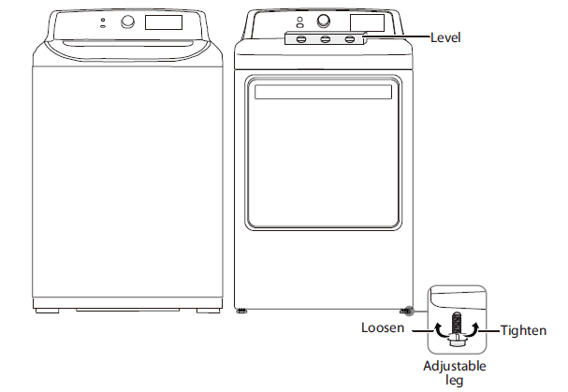
installation. Consider installing the dryer and washer
side-by-side, to allow access to the gas, electrical, and
exhaust connections. Place two of the carton
cushion-tops on the floor. Tip your dryer on its side so
it lies across both cushion-tops.

- Set your dryer back in an upright position.

- To ensure that the dryer provides the optimal drying
performance, it must be leveled. To minimize vibration,
noise, and unwanted movement, the floor must be a perfectly level, solid surface.
- Adjust the leveling feet only as much as necessary to level the dryer. Extending the leveling feet more than necessary can cause the dryer to vibrate.
- Review the “Exhausting” section on page 13 before installing the exhaust system. Install the ductwork from your dryer to the exhaust hood. The crimped end of the duct sections must point away from your dryer.
DO NOT use sheet metal screws when assembling the ducting. These joints should be taped.
Never use plastic flexible exhaust material.
Tip for tight installations: install a section of the exhaust system onto your dryer before putting it in place.
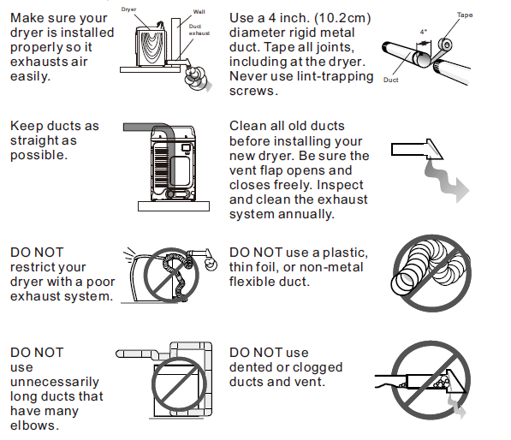
Use duct tape to secure this section to your dryer, but do not cover the ventilation slots at the back of the unit in dryer cabinet.
- Review the “Electric requirements”.
BEFORE OPERATING OR TESTING, follow the grounding instructions in the “Grounding”.
U.S. Models:
Risk Of Electric Shock - All U.S. models are produced for a 3-WIRE SYSTEM CONNECTION.
The dryer frame is grounded to the neutral conductor at the terminal block.
A 4-WIRE SYSTEM CONNECTION is required for new or remodeled construction, mobile homes, or if local codes do not permit grounding through neutral conductor. If the 4-wire system is used, the dryer frame cannot be grounded to the neutral conductor at the terminal block. Refer to the “Electric requirements” section on 3-WIRE or 4-WIRE SYSTEM CONNECTIONS.
Remove the terminal block cover plate.
Insert the power cord with a UL-listed strain relief through the hose provided in the cabinet near the terminal block.
- A strain relief must be used.
Do not loosen the nuts already installed on the terminal block. Be sure they are tight. Use a 3/8" (1cm) deep well socket.

- [GAS MODELS ONLY]
Review the “Gas requirements” section on page13. Remove the pipe thread protective cap. Apply a pipe joint compound or about 1 ½” wraps of teflon tape over all threaded connections.
  - The pipe joint compound must be resistant to the actions of any liquefied petroleum gas.
Connect the gas supply to your dryer. An additional fitting is required to connect the 3/4" (1.9cm) female thread end of a flexible connector to the 3/8" (1cm) male threaded end on the dryer.
Securely tighten the gas line fitting over the threads.
Turn on the gas supply.
- Check all gas connections for leaks using a soap solution.
- If bubbles appear, tighten the connections and recheck. DO NOT use an open flame to check for gas leaks.

- Using a level, check your dryer and make the necessary adjustments to the leveling legs.

- Make sure all gas connections (Gas Models only), exhaust and electrical connections are complete. Plug in your dryer.

- [GAS MODELS ONLY]
The burner may not ignite initially due to air in the gas line. Allowing your dryer to operate on a heat setting will purge the line. If the gas does not ignite within 5 minutes, turn your dryer off and wait 5 minutes. Be sure the gas supply to your dryer has been turned on. In order to confirm the gas ignition, check the exhaust for heat.

- Final Installation Check
- Make sure the dryer is plugged into an electrical outlet and is properly grounded.
- The exhaust ductwork is hooked up and the joints are taped.
- A plastic flexible duct in NOT used.
- Use rigid or stiff-walled flexible metal vent material.
- The dryer is leveled and is sitting firmly on the floor.
- Gas models - the gas is turned on with no gas leakage.
- Start your dryer to confirm that it runs, heats, and shuts off.

Door Reversal
Step 1: Remove the dryer door
1 Make sure that the power cord is unplugged.
2 While supporting the door, remove the four hinge screws from the door, then lift the door to remove it and set the door aside.
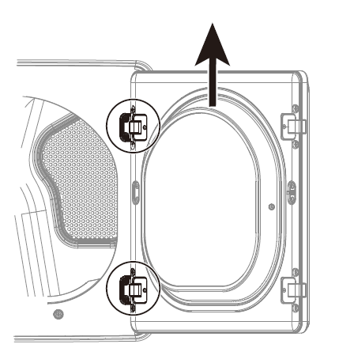

Step 2: Move the door hinges covers
1 Use a flat-blade screwdriver to remove the two hinge covers from the side that you want the door to swing from.
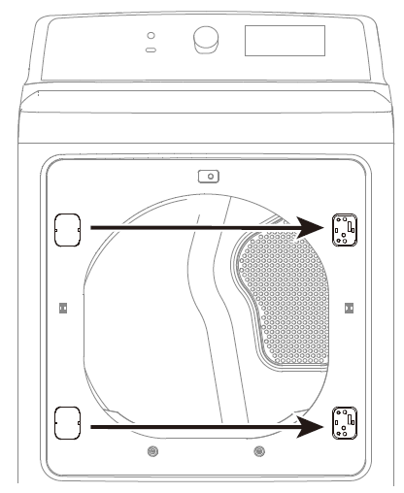

2 Install the two hinge covers on the opposite side.

Step 3: Rotate the door frame
1 Remove the 16 screws that hold the door frame to your dryer.

Note
Two of the screws secure the door latch (P) to the door frame. You will need to attach the latch when you reassemble the door.

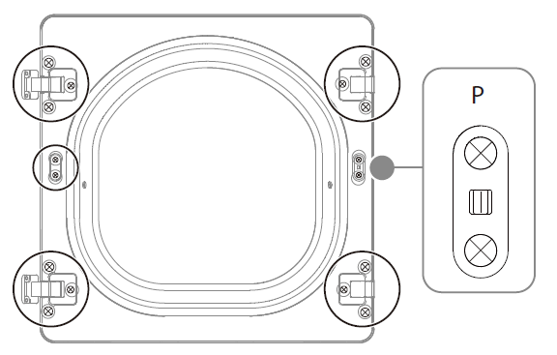
2 Move the hinges, hinge covers, and door latch to the other side of the door.
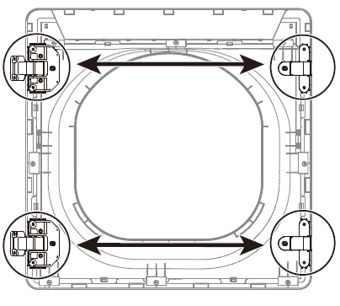
3 Secure the door frame to your dryer using the 16 screws you removed in Step 1. Make sure that you attach the door latch (P) with two of the screws.

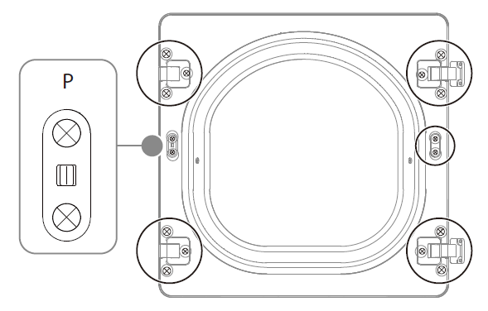

Step 4: Install the dryer door on the other side
1 Align the hinges on the door with the hinge screw holes on the front of your dryer.
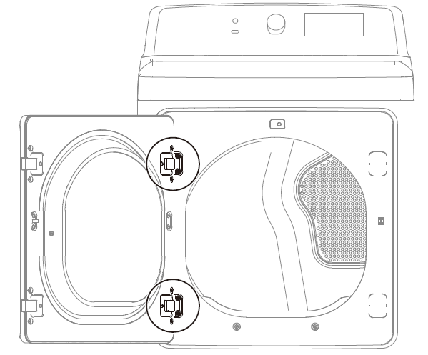

2 Secure the door with the four screws you removed in Step 1.

Step 5: Replace the door sticker on the other side
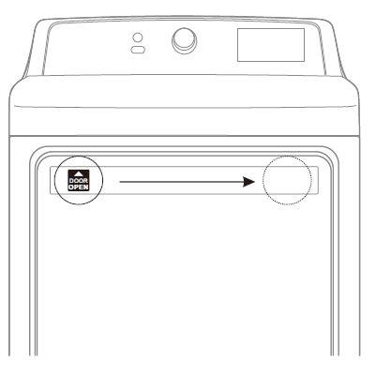

4. TROUBLE SHOOTING

4.1 Test mode by Control
Make sure the door is closed, press [Time Adjust +] and [Wrinkle Care] at the same time within 3s after press [Power] button , then unit will go into test mode, scree will show “St”.

Test modes
- Press [Time Adjust +], screen will show 01, after 0.5s, the screen will show software version;

- Press [Time Adjust +] again, screen will show 02, turn the knob to right or left to check. Every time you turn the knob, the light around the knob will change accordingly, light on or off.

- Press [Time Adjust +] again, screen will show 03, will go into key checking mode.

4. Press [Time Adjust +] again, screen will show 04, NTC test. If NTC error, error code “E5” will show up, or the screen will show current temp.

5. Press [Time Adjust +] again, screen will show 05, and unit will operate normally.

6. Press [Time Adjust +] again, screen will show Ed, and test modes end.

4.3 Error codes

Fault Code | Category | Description | Debounce | When Checked | Criteria | Action After Fault Debounced
E4 | Sensor | Humidity Error |  | Run | Control will run whole cycle with cycle default setting, and don’t need dry the cloth with humidity sensor, just use timed drying. | Will run current cycle without fault, log this error code at the end of cycle if EEPROM is aviable or display it at the end of cycle
E5 | Sensor | Outlet Temperature Sensor Error | 2 sec | Run | A/D Reading under 10(open) or over1000 (short) | 1) heater off  2) Motor off  3) Go to Fault state
C9 |  | Communication error | 110sec | Run |  | 1) heater off  2) Motor off  3) Go to Fault state

4.4 Wiring diagram and terminals
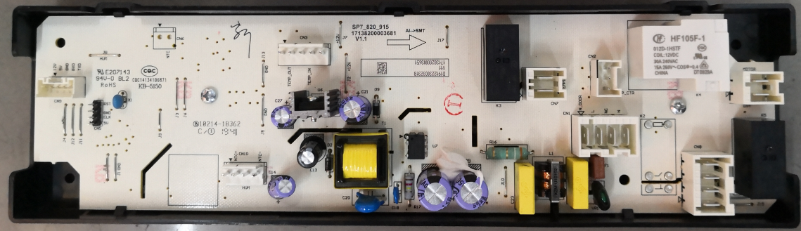
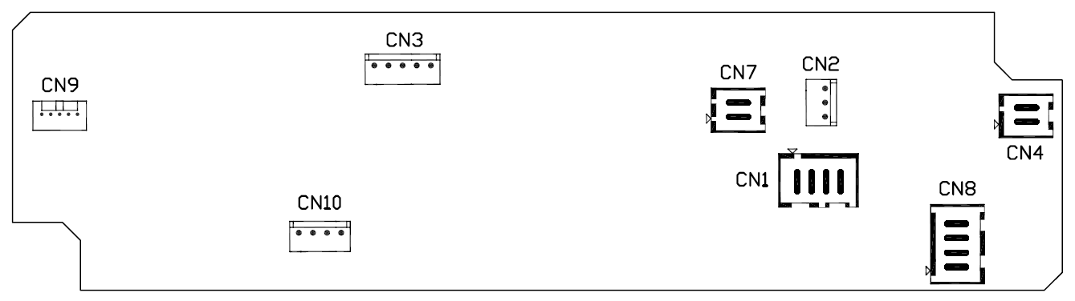

ELECTRIC MODEL
CN1 |  | DOOR SWITCH
 |  | L1
 |  | /
 |  | N
CN2 |  | 12V
 |  | /
 |  | LAMP
CN3 |  | TEMP_OUT
 |  | TEMP_OUT
 |  | TEMP_IN
 |  | TEMP_IN
 |  | /
CN4 |  | MOTOR
CN7 |  | HEATER 1
CN8 |  | HEATER 2
CN9 |  | DISPLAY COMMUNICATION
CN10 |  | HUM
 |  | GND
 |  | /
 |  | HUM
GAS MODEL
CN1 |  | DOOR SWITCH
 |  | L
 |  | /
 |  | N
CN2 |  | 12V
 |  | /
 |  | LAMP
CN3 |  | TEMP_OUT
 |  | TEMP_OUT
 |  | TEMP_IN
 |  | TEMP_IN
 |  | /
CN4 |  | MOTOR
CN7 |  | GAS HEATER
CN8 |  | /
CN9 |  | DISPLAY COMMUNICATION
CN10 |  | HUM
 |  | GND
 |  | /
 |  | HUM

ELECTRIC MODEL:
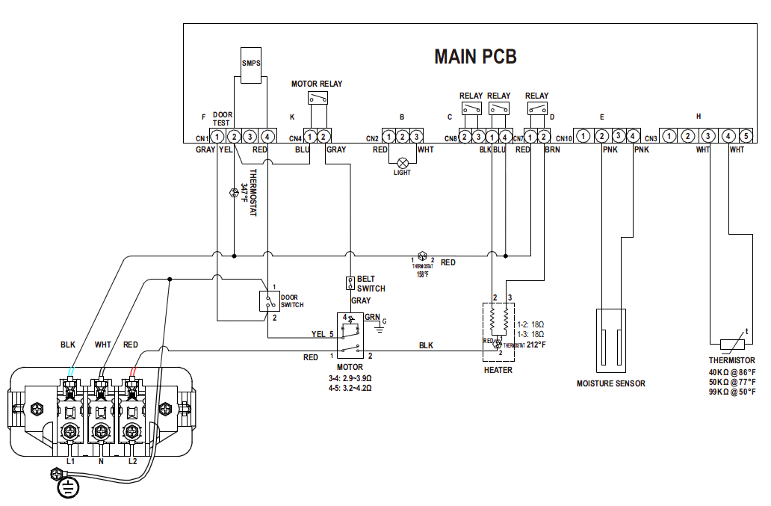
GAS MODEL:
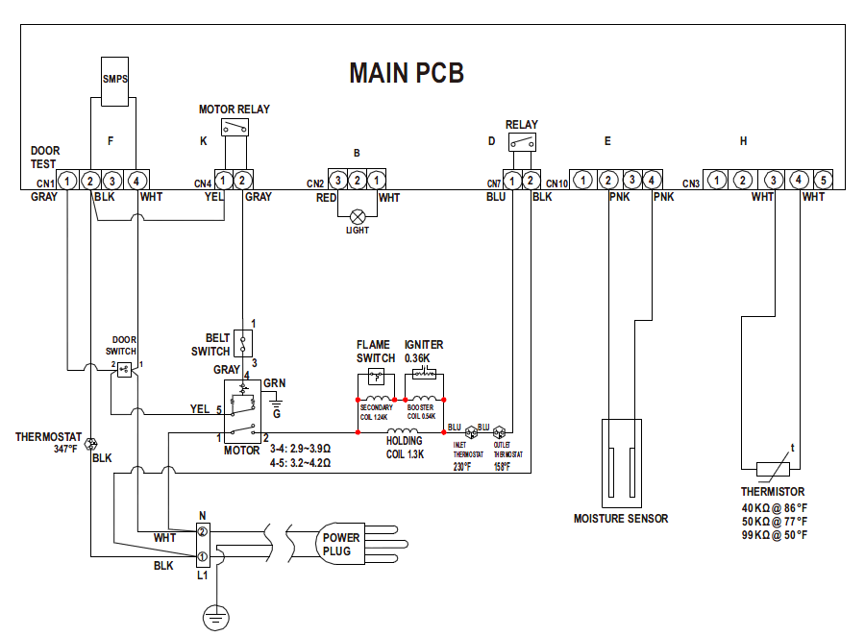

4.5 Trouble shooting
No | Problem | What To Do
1 | The unit doesn’t  start. | - Make sure the door is latched shut.  - Be sure the power cord is plugged into a live electrical outlet.  - Check the home’s circuit breaker and fuses.  - Press the Start/Pause button again if the door is opened during  the cycle.
2 | The unit doesn’t  heat. | - Check the home’s circuit breaker and fuses.  - Select a heat setting other than Air fluff and the Temp selection is not on “No heat”  - On a gas dryer, check that the gas supply is on.  - Clean the lint filter and exhaust duct.  - Dryer may have moved into the cool-down process of the cycle.
3 | Doesn’t dry. | - Check all of the above, plus...  - Be sure the exhaust hood outside the home can open and close  freely.  - Check exhaust system for lint buildup. Ducting should be inspected and cleaned annually.  - Use a 4" rigid metal exhaust duct.  - Do not overload. 1 wash load = 1 dry load.  - Sort heavy items from lightweight items.  - Large, bulky items like blankets or comforters may require  repositioning to ensure even drying.  - Load may be too small to tumble properly. Add a few towels.
4 | The unit is noisy. | - Check the load for objects such as coins, loose buttons, nails, broken zips, etc. Remove promptly.  - It is normal to hear the dryer gas valve or heating element cycle  on and off during the drying cycle.  - Be sure the dryer is leveled properly as outlined in the installation  instruction.  - It is normal for the dryer to hum due to the high velocity of air moving through the dryer drum and exhaust system.
5 | Clothes are  unevenly dried. | - Seams, pockets, and other similarly heavy areas may not be completely dry when the rest of the load has reached the selected  dryness level. This is normal. Select the Extra Dry setting if desired.  - If one heavy item is dried with a lightweight load, such as one towel with sheets, it is possible that the heavy item will not be completely dry when the rest of the load has reached the selected dryness level. Sort heavy items from lightweight items for best drying results.
6 | Shuts off before  load is dry. | - Dryer load is too small. Add more items or a few towels and restart the cycle.  - Dryer load is too large. Remove some items and restart the dryer.
7 | The unit has a  special odor. | - Household odors from painting, varnishing, strong cleaners, etc.  may enter the dryer with surrounding room air. This is normal as the dryer draws the air from surrounding air space of the dryer locations.  - When these odors linger in the air, ventilate the room completely  before using the dryer.
8 | Odors remain in  clothing after  refresh | - Fabrics containing strong odors should be washed utilizing desired wash cycle.
9 | Garments still  wrinkled after  Wrinkle-prevent | - Small loads of 1 to 4 items work best.  - Load fewer garments. Load similar-type garments.
10 | Lint on clothes | - Lint filter be cleaned before every cycle. With some loads that produce high amounts of lint, it is necessary to clean the filter after the cycle.  - Some fabrics are lint producers (for example, a fuzzy white cotton towel) and they should be dried separately from clothes that are lint trappers (for example, a pair of lack linen pants).  - Divide larger loads into smaller loads for drying.  - Check pockets thoroughly before washing and drying clothes.

COMPONENT TESTING PROCEDURES
Thermistor
Door switch
Regulating Thermostat

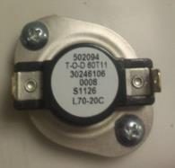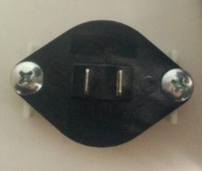
158/122°F, 25A HI-limit
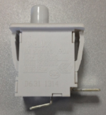
250V 16A

Regulating Thermostat resistance < 1Ω (Electric & Gas) | If resistance is infinity, replace Regulating Thermostat.
Thermistor resistance  40KΩ @ 86°F  50KΩ @ 77°F  99KΩ @ 50°F | If resistance is infinity, replace the Thermistor

Thermostat
Hi-limit

Thermostat
Thermal cut-off

Heater
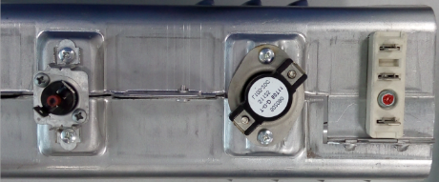
347°F, 25A Thermal cut-off

212/176°F, 25A
HI-limit
240V/5200W

Thermostat Thermal cut-off resistance < 1Ω (Electric models only) | If resistance is infinity, replace Thermostat  Thermal cut-off.
Thermostat Hi-limit resistance  < 1Ω | If resistance is infinity, replace Thermostat  Hi-limit.
Heater resistance 20 Ω | If resistance is infinity, replace Heater.

The power supply will be off if the temperature is too high. Then we need to press this red button on the thermostat to restart the dryer.

Measure resistance of the following terminals (Electric & Gas):
1. Door switch: open
Terminal: “COM” – “NO” (1-2): ∞ Ω
2. Door switch push: On
Terminal: “COM” – “NO” (1-2): < 1Ω
Belt safety switch

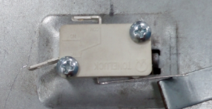
250V 16A
250V, 16A

Belt Safety Switch  (Electric & GAS) | - Lever open: Resistance value < 1Ω  - Lever push: Resistance value: ∞ Ω

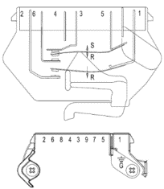
2.9~3.9Ω between
Pin# 3 and 4

3.2~4.2Ω between
Pin# 4 and 5

● Centrifugal Switch (Motor) (Electronic & GAS)
Contacts
Function | 1M | 2M | 3M | 5M | 6M
Start |  |  | ● | ●
Run | ● | ● |  | ● | ●
●=Contact closed
GAS MODELS ONLY
Flame sensor

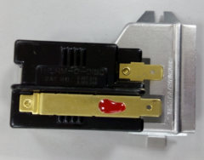
10RS 120V

Flame sensor  resistance < 1Ω | If resistance is infinity, replace Flame sensor

Igniter

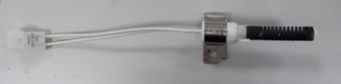
120V 60Hz
Lgniter resistance  40~400Ω | If resistance is infinity, replace igniter

Gas valve

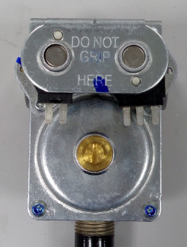
25M01A 120V 60Hz

Valve1-2: Resistance 1.2KΩ  Valve1-3: Resistance 0.5KΩ  Valve4-5: Resistance 1.2KΩ | If resistance is infinity, replace Valve.

Thermostat Hi-limit
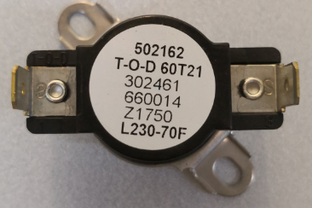
230/160F 25A (60T21)
Hi-limit

Thermostat Hi- limit resistance  < 1Ω | If resistance is infinity, replace Thermostat  Hi-limit.

Thermostat
Thermal cut-off

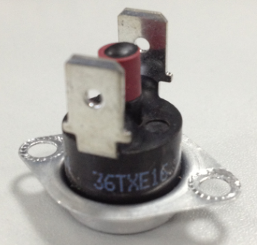
347°F, 25A
Thermal cut-off

Thermostat Thermal cut-off resistance < 1Ω | If resistance is infinity, replace Thermostat  Thermal cut-off.

The power supply will be off if the temperature is too high. Then we need to press this red button on the thermostat to restart the dryer.

5. HOW TO DISASSEMBLY THE UNIT
1.Remove the control panel  1.1 Remove the screws  that is used to fix thecontrol panel;  - Remove the screws on  the PCB cover;  - Take down the PCB  cover;  1.4 Pull out the terminals;  1.5 Take down the PCB kit. | 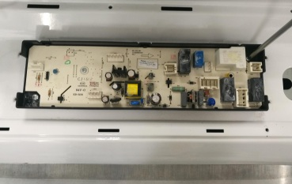  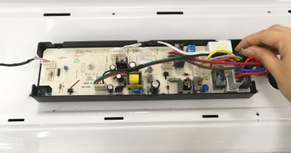  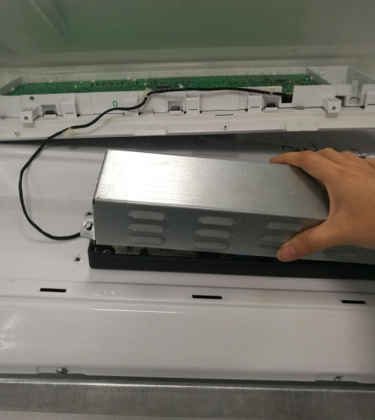  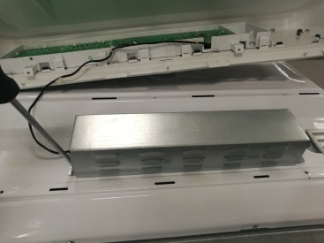  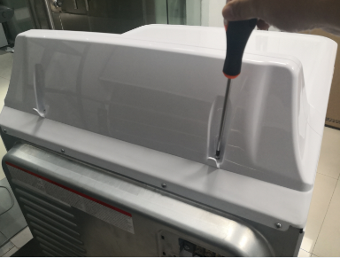  ①  ②  ⑤  ④  ③
2. Remove the top cover  2.1 Remove the screws behind the top cover;  2.2 Push off the top cover. | 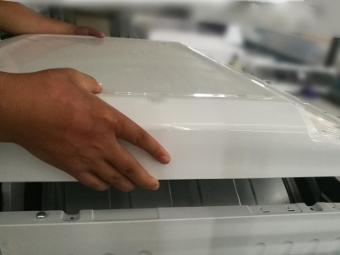  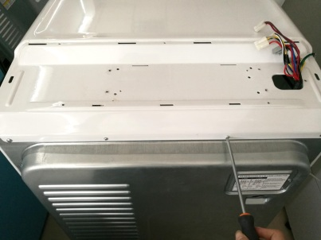  ①  ②
3. Remove the front cover  3.1 Remove the screws that is used to fix the front cover;  3.2 Take down the front cover;  3.3 Pull out the terminals connecting to the front cover. | 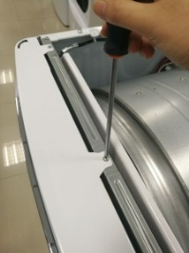  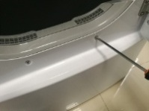  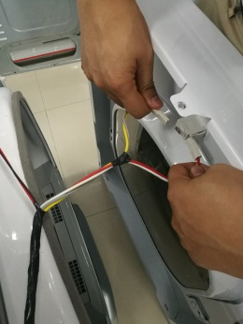  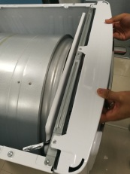  ④  ③  ②  ①
4. Remove the door assy  4.1 Remove the screws on the door hinge and take down the door assy. | 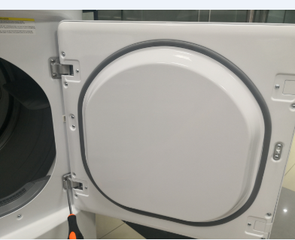
5. Remove the door pin  5.1 Remove the screws that is used to fix the door pin;  5.2 Take down the door pin. | 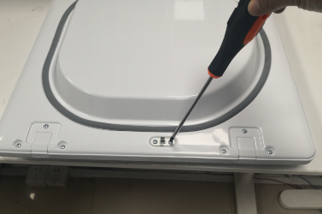
6. Deleave the door assy  6.1 Remove all screws around the door;  6.2 Depart the door front and back. | 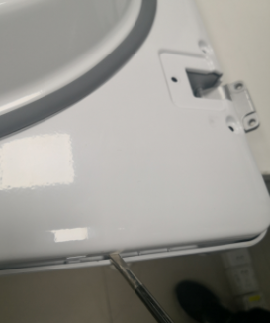  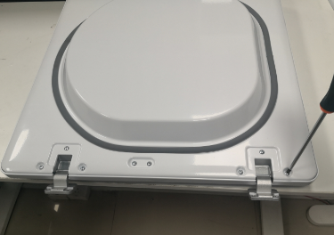  ②  ①  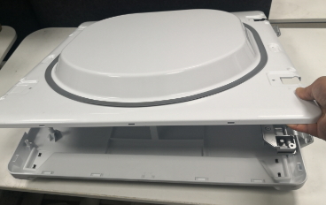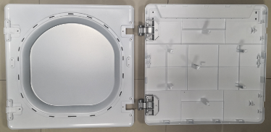  ④  ③
7. Remove the front support assy and front air flue assy  7.1 Remove the screws that is used to fix the front top rail and take down the front top rail;  7.2 Pull out the terminals connecting to the front support assy;  7.3 Remove the screws that is used to fix the front support assy ;  7.4 Take down the front support assy and front air flue assy. | 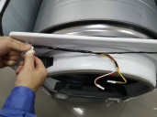  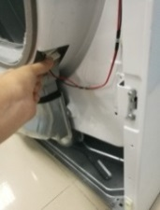  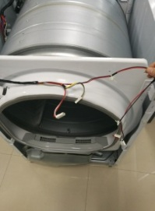  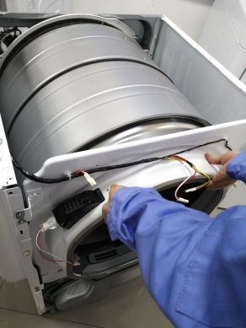  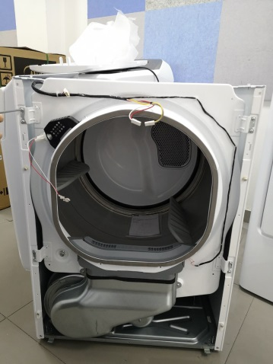  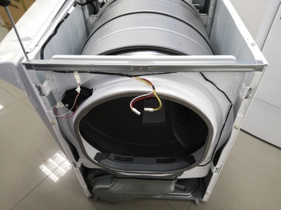  ④  ③  ②  ①  ②
8. Remove 2 front panel pins. | 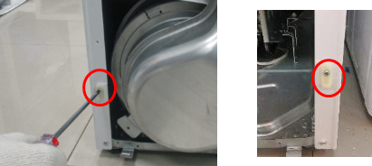
9. Remove the lamp | 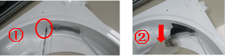
10. Take down the filter lint | 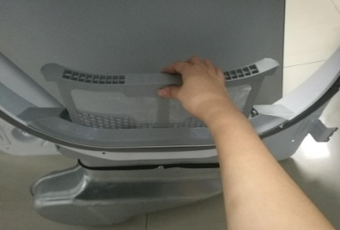
11. Remove the front air flue assy  11.1 Remove the screws that is used to fix the air flue assy;  11.2 Take down the air flue assy. | 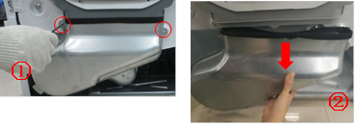
12. Take down the humidity sensor from the filter lint cover. | 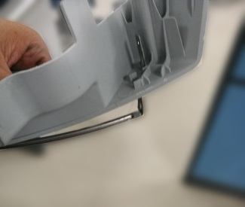  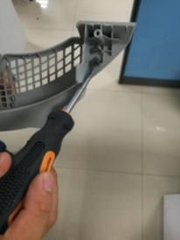  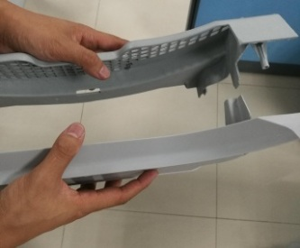  ③  ②  ①
13. Take down the tumble assy  13.1 Take down the belt from the Motor;  13.2 Hold the belt and take down the tumble assy. | 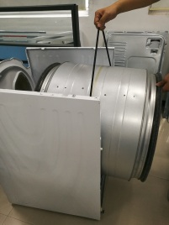  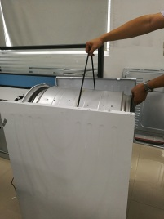  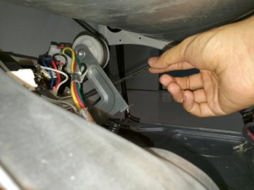  ③  ②  ①
14. Remove the motor and fan assy  14.1 Pull out the terminals;  14.2 Remove the screws fix the motor;  14.3 Take down the motor and fan assy. | 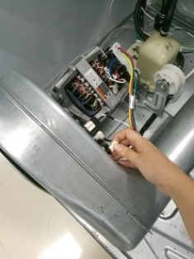  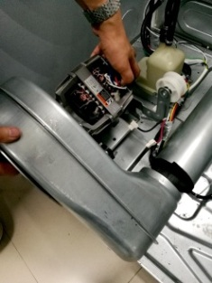  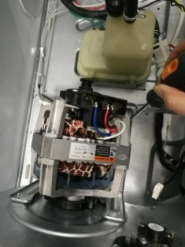  ③  ②  ①
15. Remove the temperature sensor | 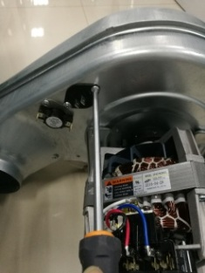
16. Remove the thermostat. | 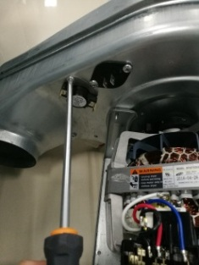
17. Remove the belt switch | 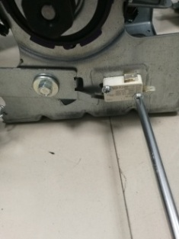
18. Remove the fixed sheet | 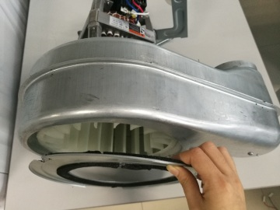  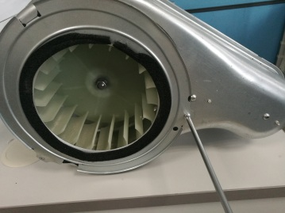
19. Remove the impeller assembly  19.1 Unscrew the locknut and take it down;  19.2 Take down the impeller Assembly. | 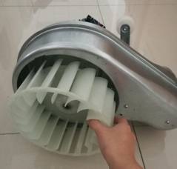
20. Remove the volute assembly  20.1 Remove the screws that is used to fix the volute assembly;  20.2 Take down the volute assembly. | 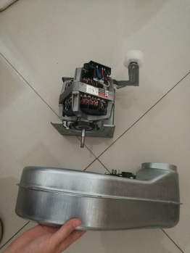  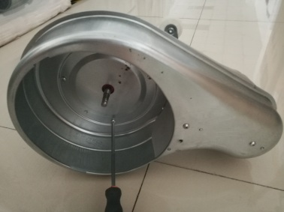
21. Remove the motor. | 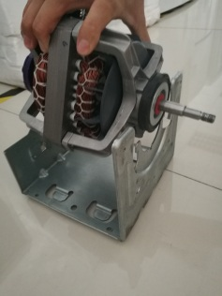  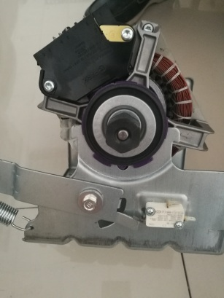  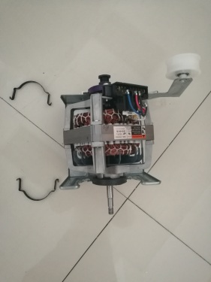  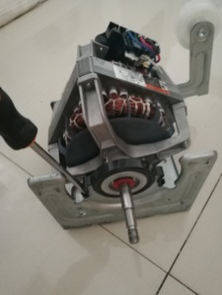  ④  ③  ②  ①
22. Remove the tensioner pulley assembly. | 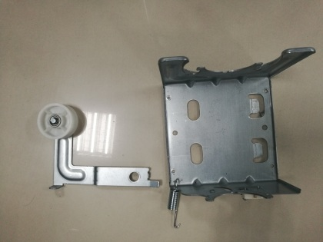  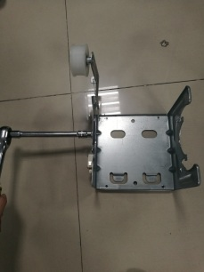
23. Remove the heater assy  23.1 Pull out all the terminals;  23.2 Remove the screw that is used to fix the heater assy;  23.3 Take down the heater assy;  24.4 Remove the thermostat. | 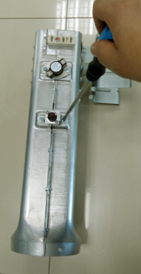  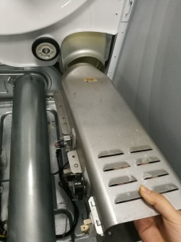  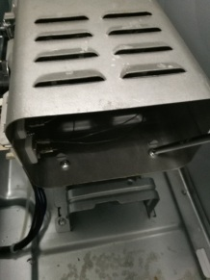  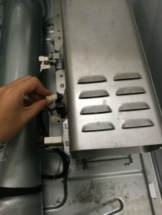  ④  ③  ②  ①
25. Take down the back air outlet  25.1 Remove the screw that is used to fix the back air outlet;  25.2 Pull out the rear vent pipe. | 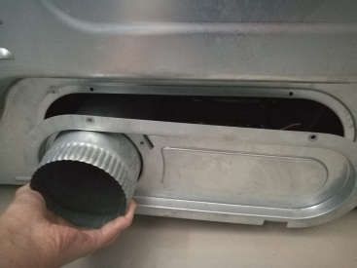  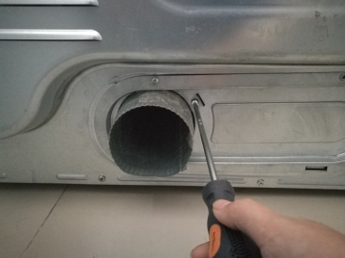
26(a). Remove the back cover  26.1 Remove the screws that is used to fix power line;  26.2 Remove the screws on the back cover;  26.3 Take down the back cover. | 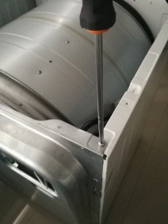  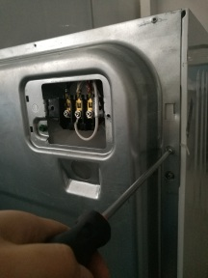  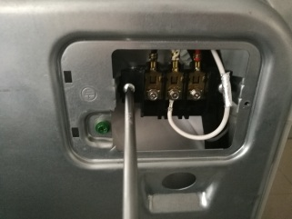  ③  ②  ①  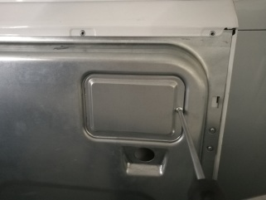  ④
26(b). Remove the back cover (Gas model only)  26.1 Remove the screws that is used to fix power line;  26.2 Pull out the terminals;  26.3 Remove the screws on the back cover;  26.4 Take down the back cover. | 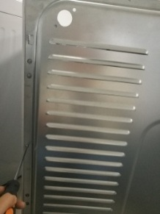  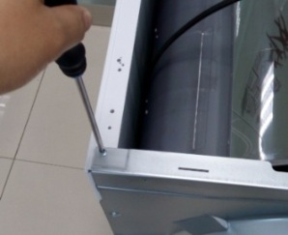  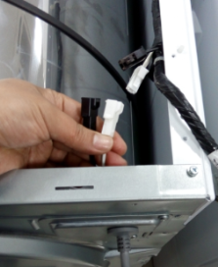  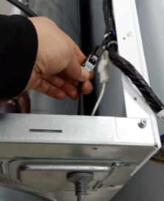  ④  ③  ②  ①
27. Remove the burner assy (Gas model only)  27.1 Pull out all the terminals;  27.2 Remove the 4 screws fixing the burner assy. | 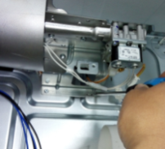  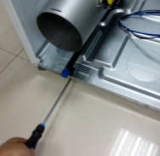  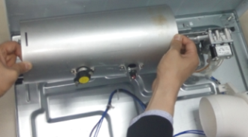  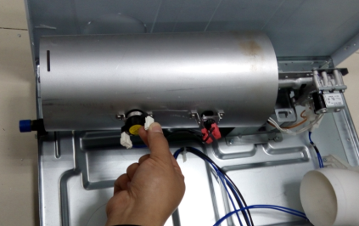  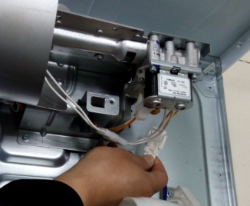  ⑤  ④  ③  ①  ②
28(a). Change the thermostats (Gas model only) | 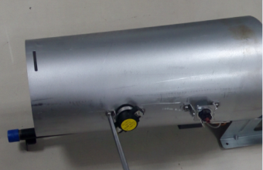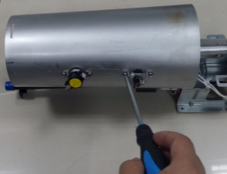
28(b). Disassemble the burner (Gas model only)  28(b).1 Remove the screws fixing the bracket;  28(b).2 Remove all terminals;  28(b).3 Pull the burner and the gas valve assy backwards, then lift it up. Take care the ignitor. | 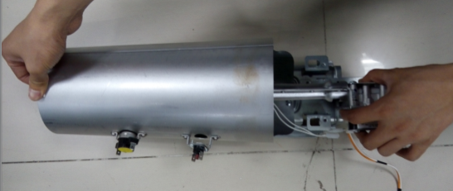  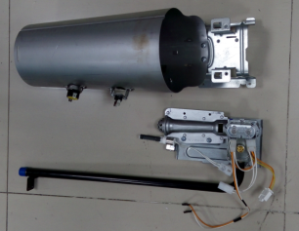  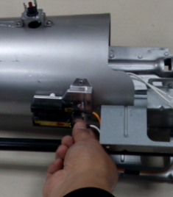  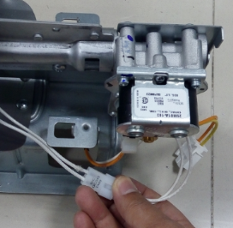  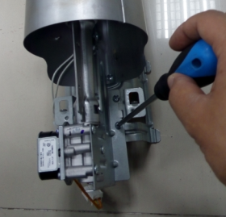  ②  ⑤  ④  ③  ①
26(c). Change the flame switch (Gas model only) | 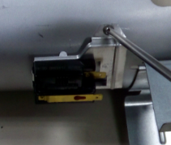
26(d). Change the ignitor (Gas model only) | 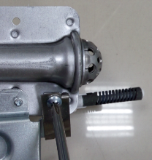  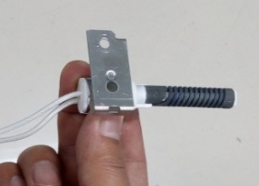  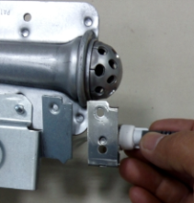  ③  ②  ①
26(e). Change the burner (Gas model only) | 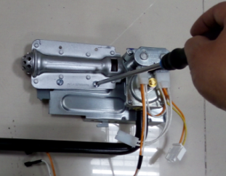
26(f). Change the gas valve (Gas model only) | 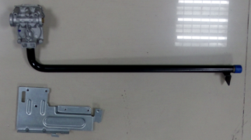  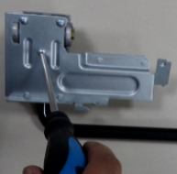  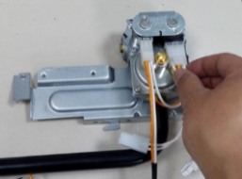  ③  ②  ①
26(g). Change the nozzle for LP (Gas model only)  26(g).1 Remove the 2 screws fixing the burner;  26(g).2 Remove the burner;  26(g).3 Remove the nozzle with spanner 3/8", torque in range from 25 to 45 in.lbs;  26(g).4 Replace the nozzle for LP;  26(g).5 Remove the valve cover from the gas valve;  26(g).6 Replace the valve bar;  26(g).7 Reinstall the burner. Take care the position between the burner and ignitor. | 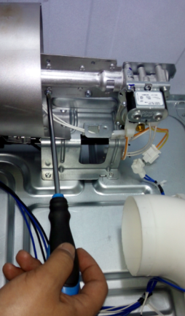  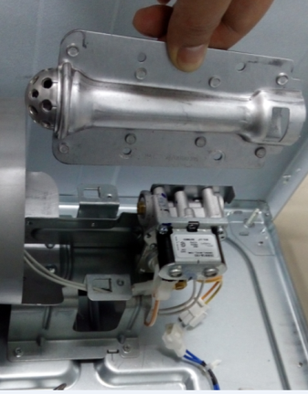  ⑩  ⑨  ⑧  ⑦  ⑥  ⑤  ④  ③  ②  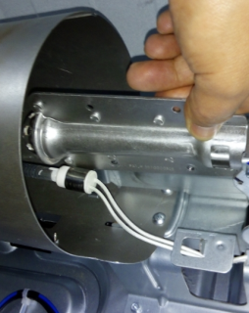  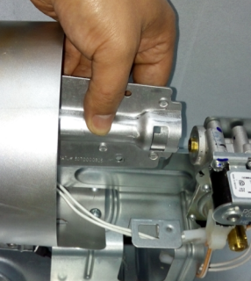  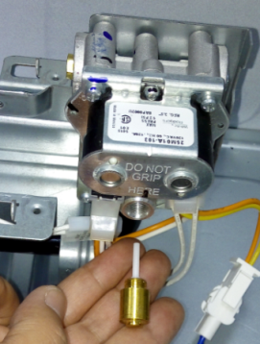  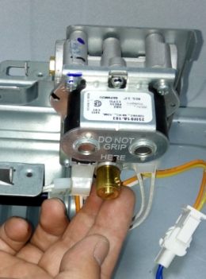  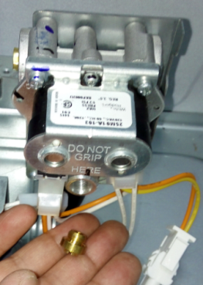  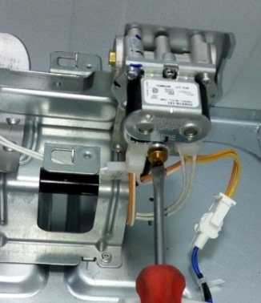  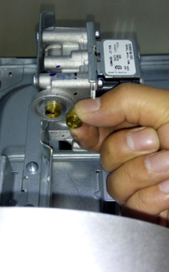  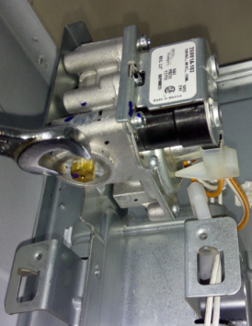  ①
26(h). Take care all ternimals (Gas model only) | 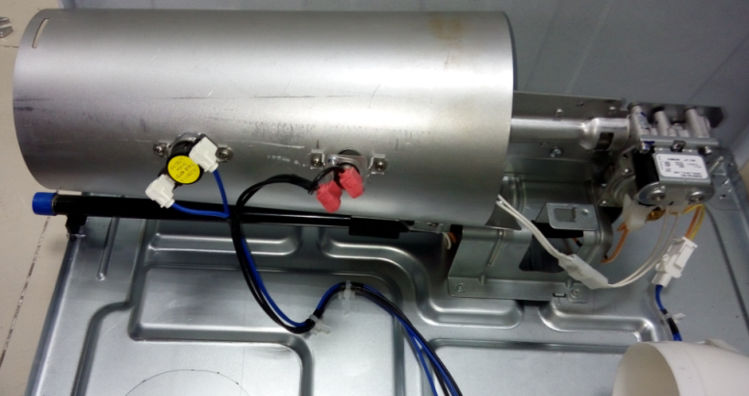
27. Remove the wheels supporting the drum. | 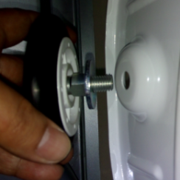  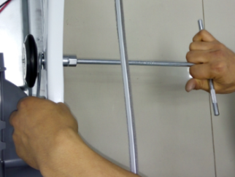  ①  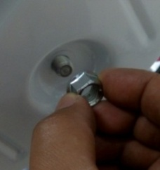  ③  ②

6. EXPLODED VIEW
ELECTRIC MODEL:

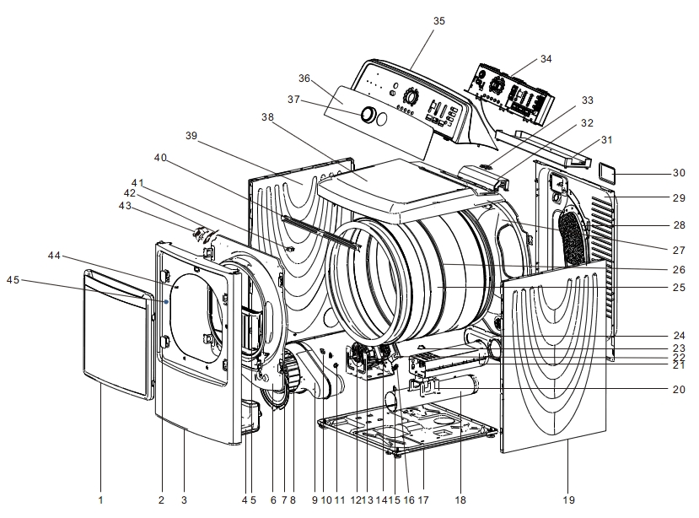
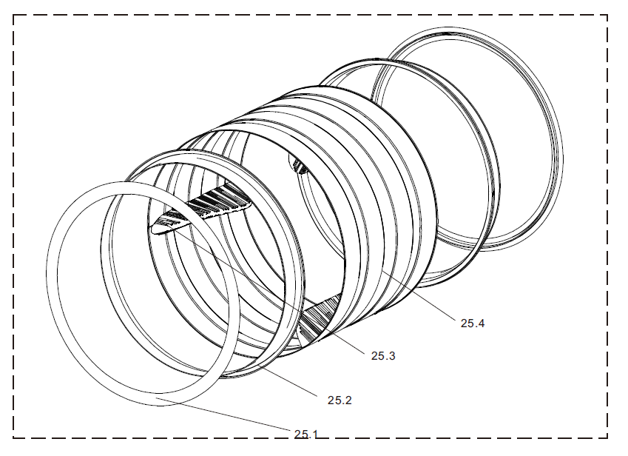

GAS MODEL:

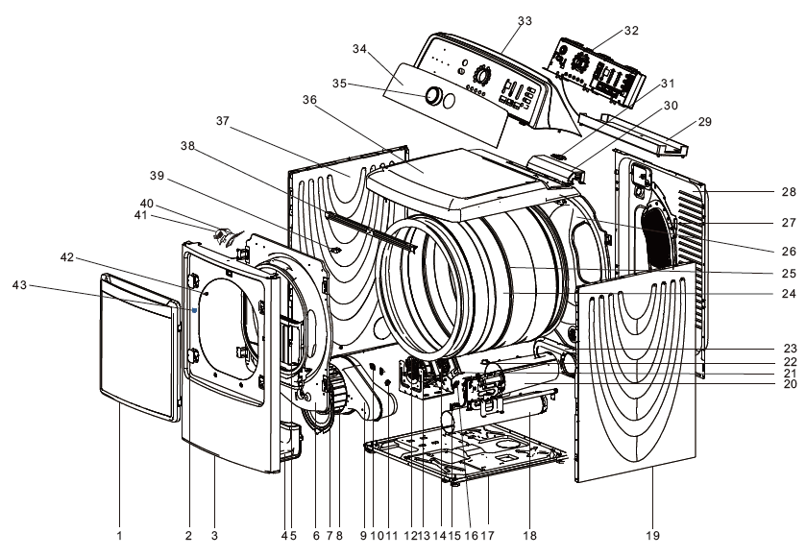
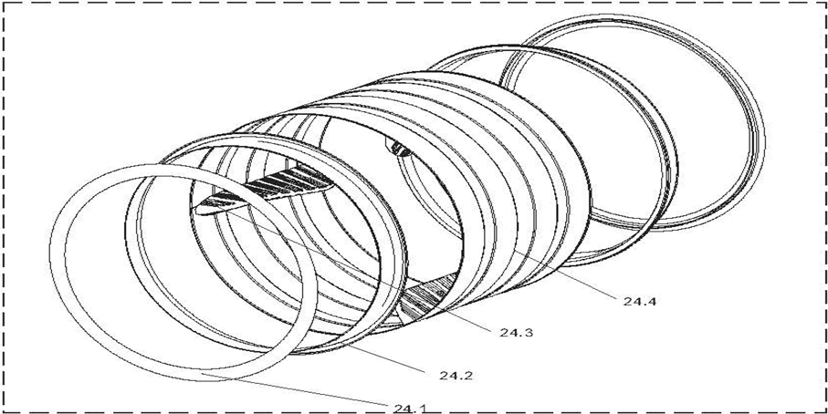
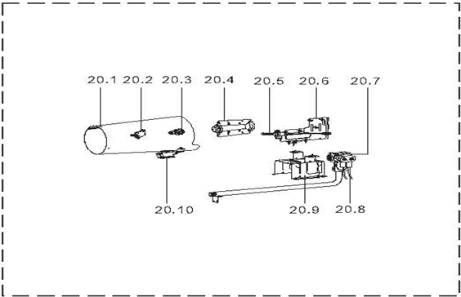

7. SPARE PART
ELECTRIC MODEL
No. | Part Name | Quantity
1 | Door Subassembly | 1.0
2 | Door Hinge Cover | 2.0
3 | Front Panel Assembly | 1.0
4 | Air Flue Assembly | 1.0
5 | Lint Filter Assembly | 1.0
6 | Front Support Assembly | 1.0
7 | Fixed Sheet Assembly | 1.0
8 | Impeller Assembly | 1.0
9 | Volute Assembly | 1.0
10 | Temperature Sensor | 1.0
11 | Thermostate | 1.0
12 | Clip Spring | 2.0
13 | Motor Support | 1.0
14 | Single phase asynchronous motor | 1.0
15 | Front Panel Pin | 2.0
16 | Spring | 1.0
17 | Base Subassembly | 1.0
18 | Rear Vent Pipe Assembly | 1.0
19 | Side Plate | 1.0
20 | Heater Support | 1.0
21 | Heater | 1.0
22 | Support For Tensioner Pulley Assembly | 1.0
23 | Safety Switch | 1.0
24 | Hole Cover | 1.0
25 | Basket Subassembly | 1.0
25.1 | Felt | 2.0
25.2 | Basket Front Cover | 2.0
25.3 | Lifter | 3.0
25.4 | Basket Wrap | 1.0
26 | Belt | 1.0
27 | Basket Support Assembly | 1.0
28 | Air Flue Assembly | 1.0
29 | Cabinet Cover Back | 1.0
30 | Power Cord Cover | 1.0
31 | PCB | 1.0
32 | Controller Board Cover | 1.0
33 | Line Speed Hole Cover | 1.0
34 | PCB | 1.0
35 | Control Panel | 1.0
36 | Control Panel Sticker | 1.0
37 | Knob Assembly | 1.0
38 | Top Cover Plate | 1.0
39 | Side Plate | 1.0
40 | Front Top Rail | 1.0
41 | Cover Switch | 1.0
42 | Cover Lamp | 1.0
43 | Lamp | 1.0
44 | Front Panel Pin | 2.0
45 | Fixed Seat | 2.0

GAS MODEL
No. | Part Name | Quantity
1 | Door Subassembly | 1.0
2 | Door Hinge Cover | 2.0
3 | Front Panel Assembly | 1.0
4 | Air Flue Assembly | 1.0
5 | Lint Filter Assembly | 1.0
6 | Front Support Assembly | 1.0
7 | Fixed Sheet Assembly | 1.0
8 | Impeller Assembly | 1.0
9 | Volute Assembly | 1.0
10 | Temperature Sensor | 1.0
11 | Thermostate | 1.0
12 | Clip Spring | 2.0
13 | Motor Support | 1.0
14 | Single phase asynchronous motor | 1.0
15 | Front Panel Pin | 2.0
16 | Spring | 1.0
17 | Base Subassembly | 1.0
18 | Rear Vent Pipe Assembly | 1.0
19 | Side Plate | 1.0
20.1 | Combustion Chamber | 1.0
20.2 | Thermostate | 1.0
20.3 | Thermostate | 1.0
20.4 | Burner | 1.0
20.5 | Lgnition Needle | 1.0
20.6 | Support | 1.0
20.7 | Gas Valve Assembly | 1.0
20.8 | Internal Wire Assembly | 1.0
20.9 | Heater Support | 1.0
20.10 | Flame Switch | 1.0
21 | Support For Tensioner Pulley Assembly | 1.0
22 | Safety Switch | 1.0
23 | Hole Cover | 1.0
24 | Basket Subassembly | 1.0
24.1 | Felt | 2.0
24.2 | Basket Front Cover | 2.0
24.3 | Lifter | 3.0
24.4 | Basket Wrap | 1.0
25 | Belt | 1.0
26 | Basket Support Assembly | 1.0
27 | Air Flue Assembly | 1.0
28 | Cabinet Cover Back | 1.0
29 | PCB | 1.0
30 | Controller Board Cover | 1.0
31 | Line Speed Hole Cover | 1.0
32 | PCB | 1.0
33 | Control Panel | 1.0
34 | Control Panel Sticker | 1.0
35 | Knob Assembly | 1.0
36 | Top Cover Plate | 1.0
37 | Side Plate | 1.0
38 | Front Top Rail | 1.0
39 | Cover Switch | 1.0
40 | Cover Lamp | 1.0
41 | Lamp | 1.0
42 | Front Panel Pin | 2.0
43 | Fixed Seat | 2.0

8. SPECIFICATION
Model No. | MDD200-V052/F01-BBY |  | MDD200-VG052/F01-BBY
ERP No. | P0000001989246 |  | P0000002172419
Picture | 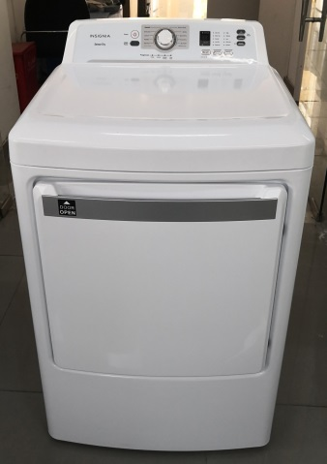 |  | 
Heater Type | Electric |  | Gas
Power Supply | 120/240V/60Hz |  | 120V/60Hz
Capacity (Cuft) | 7.5 |  | 7.5
CEF (lb/kWh/cycle) | 3.73 |  | 3.3
Certification, safety | UL |  | UL
Watts (Heater) E/G | 5230W |  | 20000 Btu/hr
input power(watts) | 300 |  | 300
Cycle selection | 10 |  | 10
Cycles | Normal, Heavy Duty, Bulky, Casual, Delicates, Towels, Sanitize, Quick Dry, Air Fluff, Time Dry |  | Normal, Heavy Duty, Bulky, Casual, Delicates, Towels, Sanitize, Quick Dry, Air Fluff, Time Dry
Options | My cycle , Dryness, Temp, Wrinkle Prevent |  | My cycle , Dryness, Temp, Wrinkle Prevent
Sensing dry | Yes |  | Yes
Temperature selection | 5 |  | 5
Dryness level selection | 5 |  | 5
digital display | Yes |  | Yes
cycle status lights | Yes |  | Yes
Remaining time display | Yes |  | Yes
Look through door | No |  | No
End of cycle signal | Yes |  | Yes
delay start | No |  | No
Memory of power interrupt | Yes |  | Yes
adjustable leg | Yes, 4 |  | Yes, 4
Drum light | Yes |  | Yes
Color | White |  | White
Reversable door | Yes, left-right |  | Yes, left-right
Exhaust Options | 3 Way(Rear ; L&B) |  | 3 Way(Rear ; L&B)
Special feature
child lock | Yes | Yes
Door switch | Yes | Yes
error alarm | Yes | Yes
auto-power off | Yes | Yes
Dimensions & loading
Width, body, Inch | 27 | 27
Depth, body, Inch | 31 1/2 | 31 1/2
Height, body, Inch | 45 4/5 | 45 4/5
Width, body, mm | 686 | 686
Depth, body, mm | 800 | 800
Height, body,mm | 1163 | 1163
Net weight, lbs | 135 4/5 | 135 4/5
Gross weight, lbs | 150 | 150
Net weight, Kg | 61.6 | 61.6
Gross weight, Kg | 68 | 68

